**Assignment -1**

Thinkercad

|  |  |
| --- | --- |
| Assignment Date | 17 September 2022 |
| Student Name | Mr. Gunaseelan |
| Student Roll Number | 910819104002 |
| Maximum Marks | 2 Marks |

**Question-1:**

Build a smart home in Thinkercad with 2 sensors, an Led, buzzer and submit it.

**Solution:**

Thinkercad Link : <https://www.tinkercad.com/things/dNVzOyrwemt-neat-amur-habbi/editel?sharecode=sgoi3KliC-a8VG5nZPlwccXE0y3w6AyNSqE2fvY8NHQ>

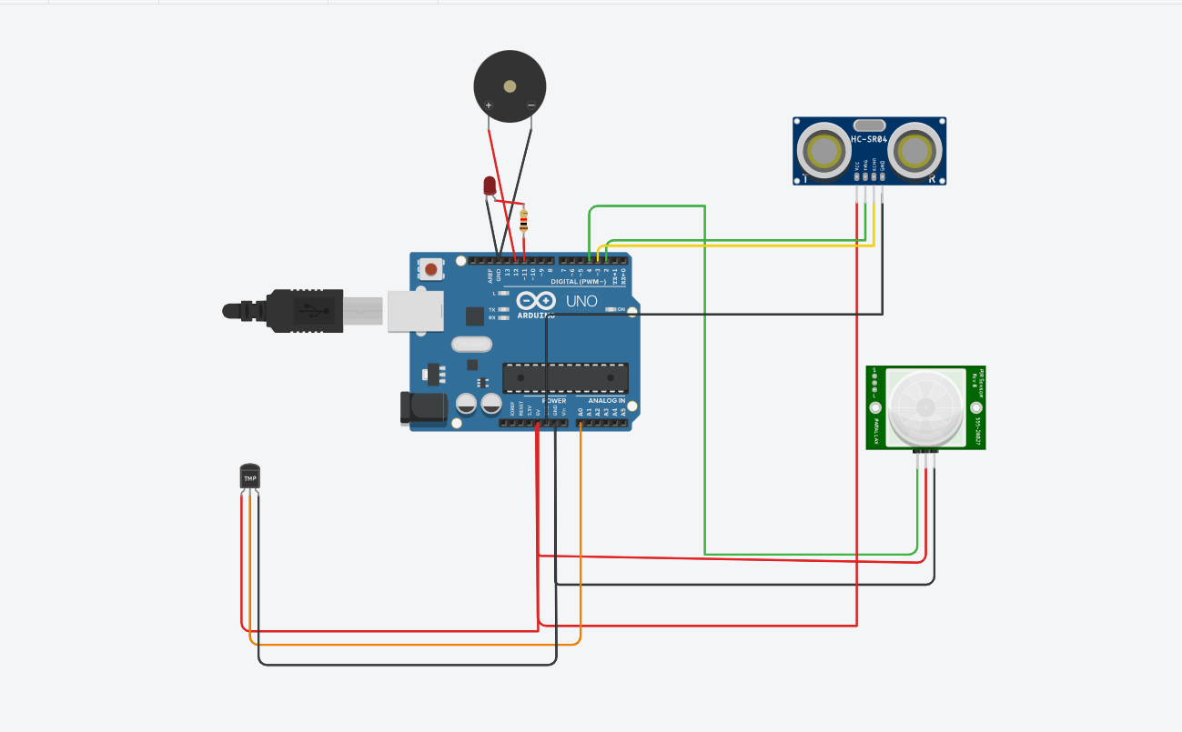

**Code:**

int t=2;

int e=3;

void setup()

{

Serial.begin(6000);

pinMode(12,OUTPUT);

pinMode(4,INPUT);

pinMode(t,OUTPUT);

pinMode(e,INPUT);

pinMode(11,OUTPUT);

}

void loop()

{

double a=analogRead(A0);

double te=(((a/1024)*5)-0.5)*100;

if(te>100)

tone(12,125);

else

noTone(12);

digitalWrite(t,LOW);

digitalWrite(t,HIGH);

delayMicroseconds(10);

digitalWrite(t,LOW);

float dur=pulseIn(e,HIGH);

float dis=(dur*0.0343)/2;

if(dis<130)

digitalWrite(11,HIGH);

else

digitalWrite(11,LOW);

int p=digitalRead(4);

if(p)

tone(12,100);

else

noTone(12);

}

**Output:**

